‘The early evidence is flashing red’: Elizabeth Warren convenes panel on military blast injuries

Experts say shock waves from low-level explosions raise risks of memory loss, suicide, and cancer
By Adam Piore Globe Staff,Updated September 8, 2024, 5:00 p.m.
26
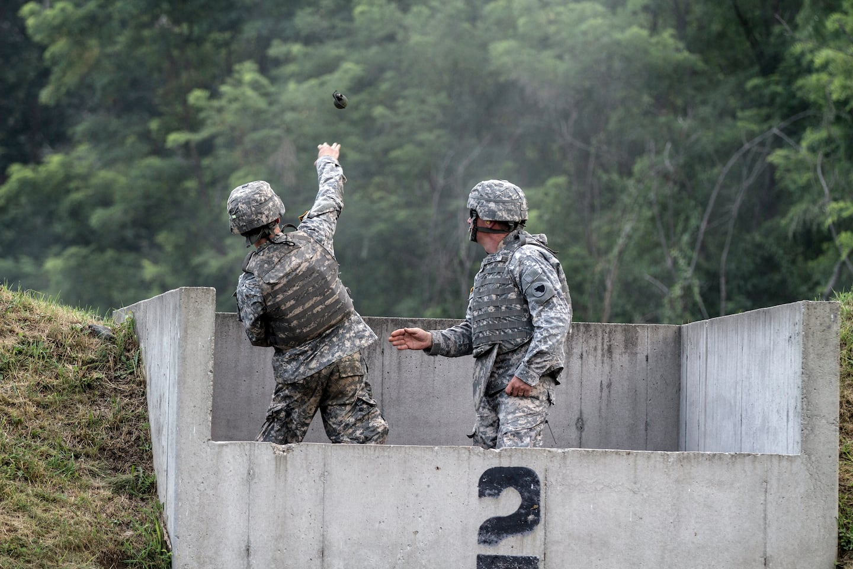In a photo provided by the US Army, a cadet at the US Military Academy at West Point, N.Y., throws a live grenade at a target under the supervision of soldiers from the 104th Training Division during the Cadet Summer Training exercise on July 27, 2015.US Army/Sergeant First Class Brian Hamilton via New York Times
Dennis Hernandez knew he was in trouble when he watched a video of himself stress-testing a security system for a client and realized he had no recollection of doing it. The video had been filmed that morning.
Hernandez, a retired special forces veteran, suspected his short-term memory problems stemmed from repeated exposures to the pressure waves unleashed by low-level explosions. During his 22 years of service, he’d been exposed to breaching charges used to blow open doors countless times, along with multiple IEDs. But when he finally sought help from the Department of Veterans Affairs, he realized he was on his own.
“I wasn’t in there more than five minutes, when the doctor told me I didn’t meet the criteria for [mild traumatic brain injury] and just moved me along,” he said. The brain specialist acted as if “I was interrupting his day.”
Advertisement

Hernandez shared his story last week at a forum hosted by Senator Elizabeth Warren aimed at highlighting the desperate need for more attention and research into the effects of “blast over pressure,” which experts define as pressure resulting from an explosive shock wave that exceeds normal atmospheric pressure.
While traumatic brain injury has been called the “signature wound” of the wars in Iraq and Afghanistan, due to the widespread use of improvised explosive devices (IEDs), it’s only in recent years that researchers have turned their attention to the impact of smaller, sub-concussive blasts. Efforts to understand their impact on the brain remain in infancy. The issue gained national attention in March, when the family of Robert R. Card II, the man who killed 18 people in a mass shooting last year in Lewiston, Maine, released the results of an analysis carried out by Boston University’s CTE Center suggesting he had traumatic brain injuries that likely influenced his actions. Card worked at an Army hand grenade training range, where he may have been exposed to thousands of low-level blasts.
Evidence is growing that repeated exposure to the pressure waves unleashed by small explosions may be linked to higher rates of suicide, along with a wide array of seemingly unrelated physical ailments, including cancer, Parkinson’s, and heart disease, Dr. Ross Zafonte, president of Spaulding Rehabilitation Network, Boston, said at the forum.
Advertisement

“There are a lot of long-term health concerns, and we’re getting good at identifying which ones they are,” Zafonte, who also serves as chief of traumatic brain injury and health and wellness programs at Home Base, a national nonprofit that provides clinical care and other support to veterans and their families. “But we now have to understand the why and how to mitigate them.”
Warren, who is chair of the Senate Armed Services Personnel Subcommittee, introduced legislation and helped secure provisions in the fiscal year 2018 and 2020 National Defense Authorization Acts that required the Department of Defense to establish and then expand a longitudinal medical study examining the effects of blast overpressure to understand how to better help service members. She also introduced new legislation that would, among other things, require DoD to conduct cognitive baseline assessments for all service members to make it easier to track their brain health over time and identify those who need interventions. Provisions of the bill were folded into the fiscal year 2025 National Defense Authorization Act, which is pending before the Senate.
Dr. David J. Smith, deputy assistant secretary of defense for health readiness policy and oversight, who also spoke at the forum, highlighted a number of new Pentagon programs aimed at addressing the issue, including the development of a field guide to promote awareness and planning to minimize exposures to low-level blasts in training, and a smartphone app called the Warfighter Brain Health Provider Toolkit, with resources to assist with assessment, evaluation, and treatment of mild brain injuries at the point of injury and beyond.
Advertisement

Last month, he said, Deputy Secretary of Defense Kathleen H. Hicks signed a policy that sets a series of new requirements designed to mitigate blast over pressure exposures, he added. Those include updated guidance on the minimum distance soldiers should be from detonations that might result in pressure waves. The Pentagon has also begun integrating blast over pressure risk into the design of weapons and the acquisition process.
Warren and others suggested plenty of other areas where they’d like to see action.
Though the military has been performing baseline cognitive testing on soldiers who deploy to combat zones since 2008, Warren said the military needs to implement a more comprehensive policy that mandates testing for all personnel regardless of deployment status, along with subsequent testing at regular intervals, so that problems can be caught earlier. She vowed to “continue to hammer” the issue.
She also referenced a series of alarming recent studies that call for more action, including those suggesting that special operations forces, one of the communities at highest risk for blast over pressure, are experiencing abnormally high rates of neck tumors and cancers, and a number of studies suggesting suicide rates for troops repeatedly exposed to blasts are substantially higher.
“The early evidence is flashing red,” she said, “And I’m very concerned our current suicide strategy does not take into account the possible link between blast overpressure and suicide risk. We can’t wait until we finish all the research.”
Chris Nowinski, a former professional wrestler who runs a Boston-based concussion research foundation, helped found BU’s CTE Center, and was not present at the hearing, noted that the study, diagnosis, and treatment of traumatic brain injury have become more of a priority after years of being “severely” underfunded. But most of the focus has gone to severe traumatic brain injuries.
Advertisement

“There are still veterans being told that they don’t have a traumatic brain injury because there’s not one in their record,” he added. “We aren’t asking questions around non-concussive exposure in most places.”
Hernandez, the former special forces operator, said he was eventually able to get the medical help and support he needed from Home Base, one of the nonprofits that has received federal funding from grants Warren has supported. That helped make it possible for him to start a company and complete a master’s degree in computer science at Northeastern University. But he worries about other veterans.
“My journey has shown me the critical importance of proper diagnosis, treatment, and support for those suffering from blast-related injuries,” he said. “I stand before you not just as a veteran but as a testament to the resilience and recovery that is possible with the right care. However, for every success story like mine, there are countless others who continue to struggle in silence.”

